July 2018

*Programs Subject To Change*

Sun  7/1/18 |  | Monday  7/2/18 |  | Tuesday  7/3/18 |  | Wednesday  7/4/18 |  | Thursday  7/5/18 |  | Friday  7/6/18 |  | Saturday  7/7/18
10:30 Set Back Card Game...........…….E2  11:15 Horse Shoe..…E2  2:00 4th of July Art Craft……………...E2  3:00 Balloon Volley……………E1  4:00 Ring Toss…….E1 |  | 10:15 Ring Toss…………E1  10:30 Dutch Shuffle Board…E2  11:00 Patriotic Trivia……….E1  2:00 I Love American Jingo………………..…E1  3:15 Watercolors w/ Paul…EDR  5:45 Sing A-Long………...E1  6:15 Noodleball………….E2  6:15 Bingo……..ARFR |  | 10:30 Celebrate America................EDR    2:30 Catholic Mass…..EDR    3:15 Fun & Fitness…..E2DR  3:30 To America w/ Love video…………………E1 |  | 10:30 4th July Trivia……E1  1:40 Skeeball…………..E2    2:00 Veterans Hour……ARFR  2:30 Attwood Baking…..EDR |  | 10:15 Word Challenge………..E1SA  10:30 Tom Alvord…….E2    11:00 Patriotic Songs………………E1SA  2:00 Yoga……………E1  2:00 L-R-C………….E2  2:00 Resident Forum…………..…EDR  3:00 Holiday Trivia Social…………ATWD |  | 10:30 Bowling………..E2  10:45 Rummikub………N    2:30 Bingo………..E2DR  4:00 Balloon Volley…….E1  5:45 Sing A-Long……….E1 |  | 10:45 Arts & Crafts………..NDR  2:00 Bingo….NDR  4:00 Noodleball……E2
Sunday  7/8/18 | Monday  7/9/18 |  | Tuesday  7/10/18 |  | Wednesday  7/11/18 |  | Thursday  7/12/18 |  | Friday  7/13/18 |  | Saturday  7/14/18
10:30 Homemade Bubbles!..........E2    2:00 Family Feud…………..E2  4:00 Noodleball…E1  5:45 Heartwarming Stories…………..E1  6:15 Brain Games………….E2 | 10:15 Let’s Get Moving…E1SA  10:20 Eucharistic  Visits….............N  10:40 Eucharistic  Service…………....E2DR  11:00 Eucharistic    Service………..….EDR  11:10 IN2L Challenge…..E2  11:30 Horse Shoe……….E2  2:30 Patio Social………….E1/E2  3:45 Balloon Volley…..…..E1  5:45 Famous Lyrics………..E1  6:15 Hangman………………E2  6:15 Bingo………...ARFR |  | 10:15 Horseracing……….E1  10:30 Balloon Volley……E2  10:45 Kings In A Corner...N    2:15 Congregational Service……..EDR  3:15 Fun & Fitness…E2DR  4:00 Word Challenge….E2 |  | 10:30 Kathy Gregory……E2  10:30 Music Therapy…….E1  1:15 Table Toppers  1:30 Healing Hands/1:1 Connections……………  2:15 Patriotic Tic-Tac-Toe..E1  2:30 Attwood Baking…EDR  4:00 Categorically Correct..E2  5:45 Sing A-Long………E1  6:15 Basketball…………E2  6:15 Bingo…….ARFR |  | 10:15 Morning Stretch….E1  10:30 Rosary………….E2  11:00 IN2L Challenge…E2  11:00 Twenty Questions...E1  11:15 Hockey………..E2    2:00 Wild West Party…EDR    3:00 Attwood Social |  | 10:30 Bowling….…..E2  2:30 Bingo…………E2DR  4:00 Pictionary…………E1  5:45 Noodleball…………E1  6:15 Heartwarming Stories………………E2 |  | 10:00 Out trip Concenter to N.B. Museum  2:00 Bingo…….N  4:00 Word Challenge……E1  5:00 Don Olsen……...EDR

Sunday  7/15/18 | Monday  7/16/18 | Tuesday  7/17/18 | Wednesday  7/18/18 | Thursday  7/19/18 | Friday  7/20/18 | Saturday  7/21/18
10:30 Balloon Volley…………E2  12:30 Out Trip New Britain Bee’s Game  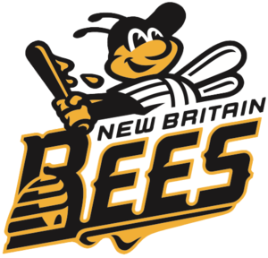  2:00 Penny Ante…E2  4:00 Ring Toss…….E1  5:00 Chip Ames……………EDR  6:15 Hangman…..E2 | 10:30 Eucharistic  Visits…...........N  10:40 Eucharistic  Service…………..NDR  11:00 Eucharistic  Service………..…EDR  11:15 IN2L Challenge………E2  2:00 Dominos………..E2  3:15 Watercolors w/Paul…………….EDR  5:45 Heartwarming Stories…E1  6:15 Bingo…….ARFR | 10:30 Toss Across…….E2  10:45 Balloon Volley…..E1  11:15 Concentration…….E2  2:00 Starting with the letter game…………….……E2  3:15 Fun & Fitness…E2DR | 10:45 American Jingo…..E2  1:30 1:1 Connections……E1  2:30 Attwood Baking…EDR  2:30 Family Feud………E2  4:00 Hockey……………E2  5:45 Heartwarming Stories………………….E1  6:15 Famous Lyrics……E1  6:15 Bingo………ARFR | 10:30 Ring Toss……...E2  10:45 American Stretch & Trivia…………………E1  11:15 IN2L Trivia……E2  2:00 Jenga…………E2  3:00 Attwood Social | 10:30 St. Marks…..EDR  11:15 Bowling………..E2  2:00 Penny Ante……..N  2:30 Bingo…….E2DR | 10:45 Trivia & Brain Teasers…..N  2:00 Bingo…..N  4:00 Trivia…..E2  5:45 Heartwarming Stories………E1  6:15 Sing Along..E2

Sunday  7/22/18 | Monday  7/23/18 | Tuesday  7/24/18 | Wednesday  7/25/18 | Thursday  7/26/18 | Friday  7/27/18 | Saturday  7/28/18
10:45 Trivia & Brain Teasers…………E2  11:15 Hockey…E2  2:00 Math Dice Game……….A2  4:00 Music & Motion…………E1  5:45 IN2L Challenge…….E1  6:15 Food Trivia……….E2 | 10:15 Bullseye…………..E1  10:30 Eucharistic  Visit……………..N  10:40 Eucharistic Service……………….E2DR  11:00 Eucharistic  Service…………….EDR  11:15 Finish the Melodies Quiz…………………E2  2:00 UNO………………….E2  2:30 Bingo……………….EDR  6:15 Bingo…………ARFR | 10:30 Bob Moseback…..E1  10:30 Balloon Volley….E1  10:30 Basketball……..E2  10:45 Card Games……..N  1:30 Out Trip…………..E1  3:15 Fun & Fitness………..E2DR | 10:15 Mind and Body Stretch……………………E1  10:30 Music Therapy…………….E2  11:00 Name that Tune…..E1  2:15 Show Me the Money………………..E1  2:30 Ukulele w/ Mia…..E2  2:30 Attwood Baking…..EDR  4:00 Dutch Shuffle Board………………….E2  5:45 Sing A Long………E1  6:15 Poetry……………...E2 | 10:30 First Lutheran………..EDR  11:15 Music & Trivia….E2  12:00 Men’s Luncheon………..ARFR  2:00 Yoga…………..E1  2:00 Coin Hole………E2  2:30 Show Me The Money……………….NDR  3:00 Attwood Social | 10:30 Llama Visit……(All)  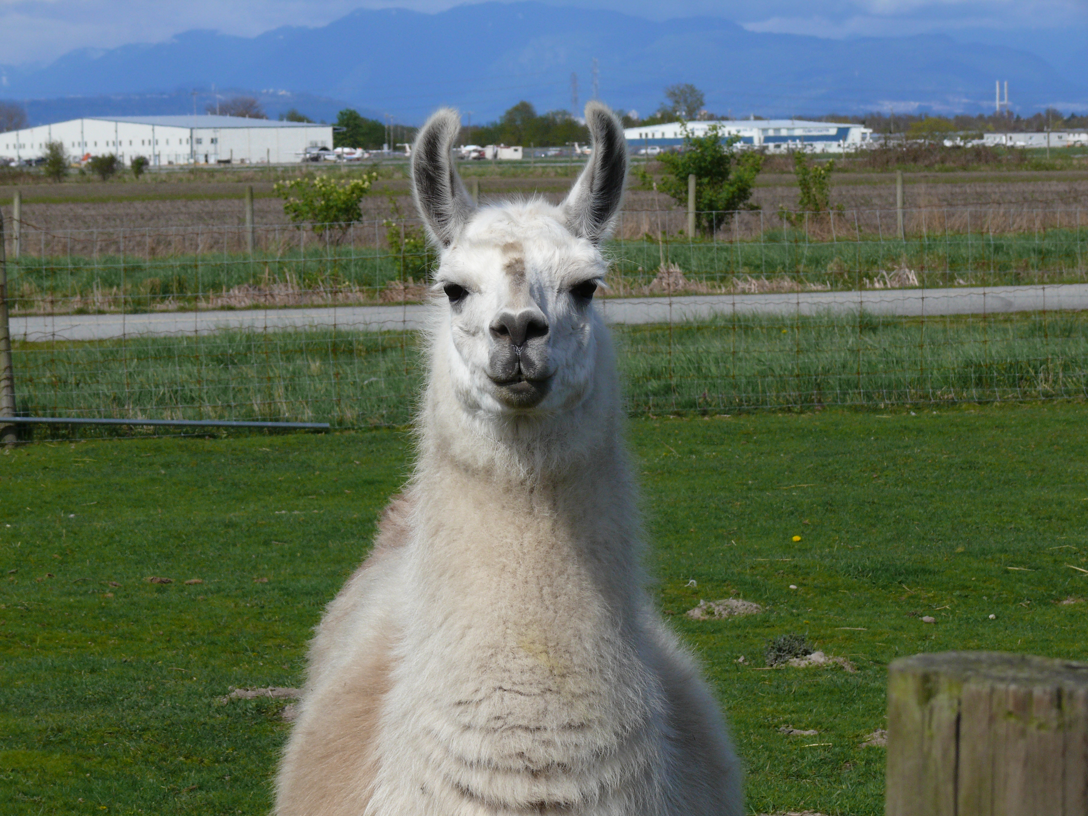  2:30 Bingo………E2DR  4:00 Ring Toss……..E1  5:45 Noodleball……..E1  6:15 Finish the Line…..E1 | 10:45 Mind & Body Exercise……E1  2:00 Bingo…..N  4:00 UNO……E2  5:00 Don Olsen………..EDR

Sunday  7/29/18 | Monday  7/30/18 | Tuesday  7/31/18
10:30 Arts & Crafts………….E2  11:15 Dutch Shuffleboard…..E2  2:00 Sunshine Strolls……E1/E2  4:00 Pictionary..E1  5:45 Toss Across…………E1  6:15 Hangman…E2 | 10:15 Basketball………….E1  10:30 Eucharistic  Visit……………..N  10:40 Eucharistic Service……………….E2DR  11:00 Eucharistic  Service…………….EDR  11:15 Table Toppers……E1  2:00 Family Fued……….E2  2:15 Scrabble…………E1  6:15 Bingo……..…ARFR | 10:30 Kathy Gregory….E1  10:30 Balloon Volley…..E2  10:45 Kings In A Corner…………………N  2:00 I Remember……E2  3:15 Fun & Fitness………...E2DR  2:15 RSVP Singers….EDR

PROGRAM LOCATIONS
E1L-East One Lounge… EDR – East Dining Rm… E1SA- East One Sitting Area
E2L-East Two Lounge…. E2DR – East Two DR…E2SA – East 2 Sitting Area
NDR-North Dining Room….A2-Attwood 2 Gathering

Your Recreation Staff

Maura Ciccotti, Claudia D’Onofrio, Lauren Meister, Mia Lenois, Jenna Sweet

