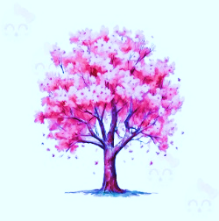 |  | 1)  10:00 Move & Groove  11:00 Fun with Words  1:30 Mad Libs Monday  2:30 Sunny Stroll | 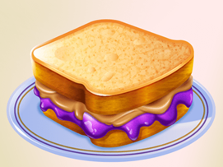  2)  10:00 GoodLife Fitness  11:00 Penny for Your Thoughts  2:00 Music/Howie Therriault  3:30 Left Right Center | 3)  10:00 Exercise  11:00 Wacky Wednesday News  2:00 Catholic Mass/JH  3:00 Sunny Stroll | 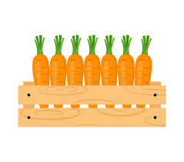  4)  10:00 Goodlife Fitness  11:00 Carrot Trivia  2:00 Music/Jon Condie  3:30 Snowball Fight | 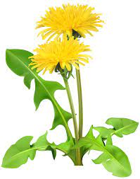  5)  10:15 Chair Yoga  11:00 Dandelion Trivia  2:00 Music/JWP Band  3:30 Tea and Snacks | 6)  10:00 Move to Music  11:00 Manicures  1:30 Hand Messages  3:00 Table Games
7)  10:00 Stretch & Tone  11:00 Outdoor Gardening  1:30 Bingo/JH  3:00 Left Right Center | 8)  10:00 Exercise  10:45 Eucharist  2:00 Bingo  3:30 Sunny Stroll/Frisbee Throw |  | 9)  10:00 Goodlife Fitness  11:00 Tuesday Trivia  2:00 Music/Lynn Tracy  3:30 UNO | 10)  10:00 Move & Groove  11:00 Hang Man  1:30 Out Trip | 11)  10:00 Goodlife Fitness  11:00 Penny for your Thoughts  2:00 Music/Bill Benson  3:30 Sunny Stroll/Frisbee Throw | 12)  10:15 Pianist Rick Daddario/JH  1:30 Sunny Stroll  2:30 Gardening in Courtyard  3:30 Outdoor Frisbee | 13)  10:00 Stretch & Tone  11:00 Manicures  1:30 Table Games  3:30 Court Yard Walk
14)  10:00 Chair Yoga  11:00 Word Games  1:30 Bingo/JH  3:00 | 15)  10:00 Move & Groove  10:45 Eucharist  2:00 Bingo  3:30 Word games |  | 16)  10:00 Goodlife Fitness  11:00 Memory Match  2:00 Music/Matt Bureau  3:30 UNO | 17)  10:00 Exercise  11:00 Wacky Wednesday News  2:00 South Church  3:30 Left Right Center | 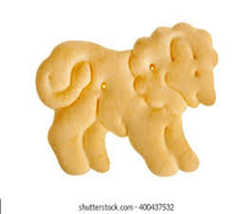  18)  10:00 Goodlife Fitness  11:00 Animal Cracker Trivia  2:00 Music w/Chris&Carol  3:30 UNO | 19)  10:00 Canned Good Weight lifting  2:00 Casino Theme Party  3:30 House cleaning/organizing | 20)  10:00 Move to Music  11:00 Manicures  1:30 Crafty Corner  2:30 Sunny Stroll
21)  10:00 Stretch & Tone  11:00 Noodle Ball  1:30 Bingo/JH  3:00 Tomato Planting  4:00 UNO | 22)  10:00 Exercise  10:45 Eucharist  2:00 Eleanor Buck Nature  3:30 Sunny Stroll/Frisbee Throw |  | 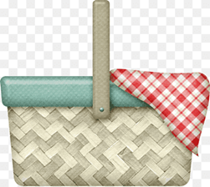  23)  10:00 Goodlife Fitness  11:00 Tuesday Trivia  2:00 Music/Mic Iarusso  3:30 Guess what’s in my basket | 24)  10:00 Chair Yoga  11:00 Hang Man  1:30 Out Trip | 25)  10:00 Goodlife Fitness  11:00 A Penny for Your Thoughts  2:00 Music/Chip Ames  3:30 Uno | 26)  10:15 Pianist Rick Daddario/JH  1:30 Hang Man  3:00 Garden Maintenance | 27)  10:00 Move & Groove  11:00 Manicures  1:30 Hand messages  2:30 Left Right Center
28)  10:00 Move to Music  11:00 Sing-a-Long  1:30 Bingo/JH  3:30 Sunny Stroll | 29)  10:00 Canned good weight lifting  10:45 Eucharist  2:00 Bingo  3:30 Sunny Stroll/Reminisce |  | 30)  10:00 Goodlife Fitness  11:00 Indoor Frisbee  2:00 Music/Bob Aresti  3:30 Crafty Corner | APRIL
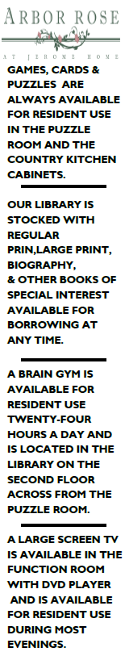
30

